Global Choice

Essay Rough Draft Everything is Awesome:

Opportunity for change - The change in our living environment leads to new challenges that offer opportunities for the future. Therefore, despite all the negative news, there are also many good things that arise and positively influence the present and the future. However, many people are afraid of change and try to hide this fear by having a bad view of things. As a result, they don't see that this is the absolutely best time to shape the future better and to learn from mistakes. This can be seen very well using the example of the current pandemic. 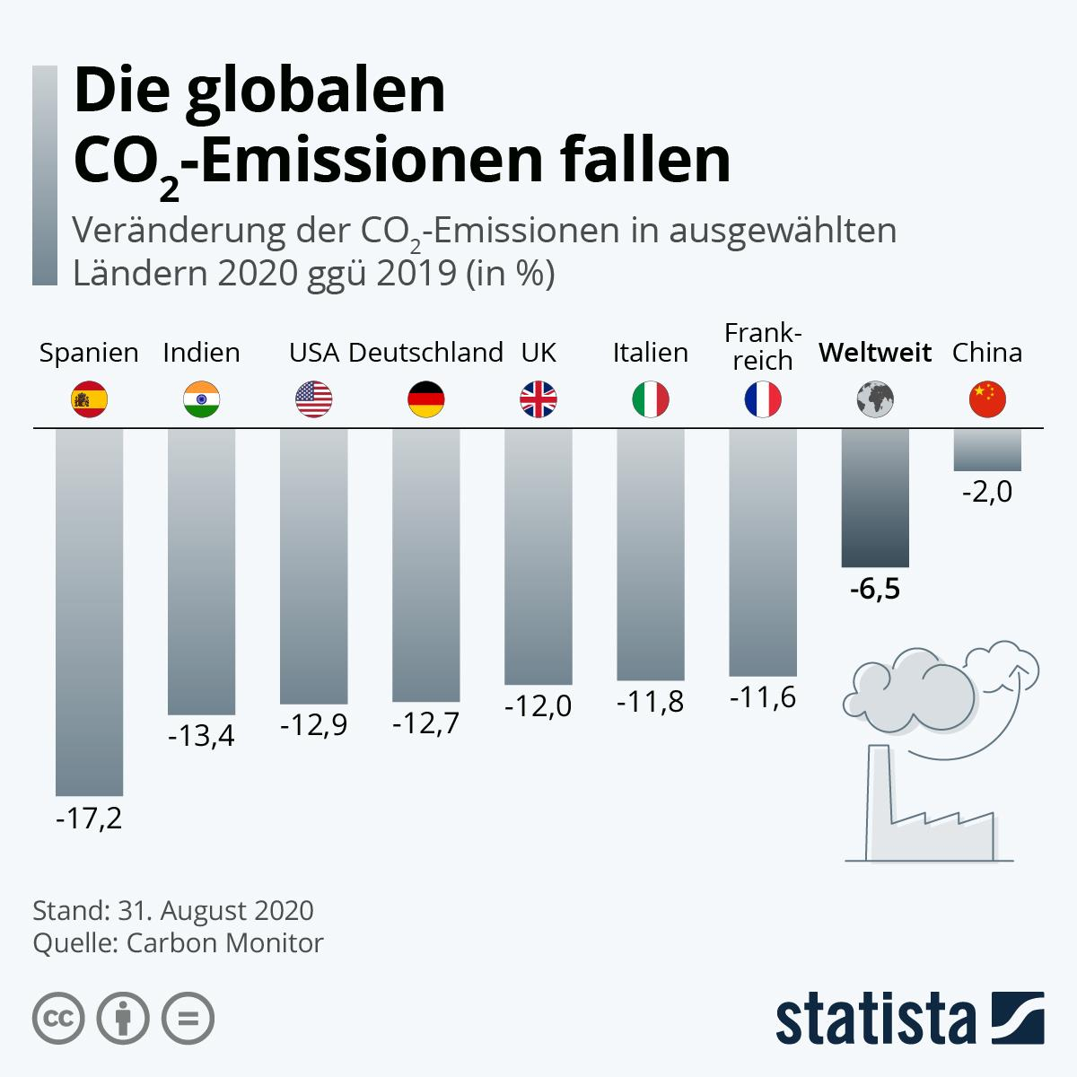

Due to the stay at home orders, the schools had to develop new ways of learning very quickly. Online learning has been greatly expanded, as on-site learning is not possible or is only possible to a limited extent. That also has advantages! Many people claim that the students are not educated well and get lazy. But it is often the case that the new online learning means that students have greater personal responsibility and have to show discipline. You will learn how to use the new media even more intensively than before. Since there is no longer a trip to school, the students have more time for the many homework and can also take part in the lessons more rested. They can also solve the set tasks at their own pace, but have to meet deadlines. It is undoubtedly a fact that social contact with other students is limited. But especially in the last few years the social networks have developed so strongly that even communication across continents is not a problem. And a lot was already running on these digital networks before the pandemic.

There have also been many changes for the economy due to the statutory provisions. The employees were sent to the home office and could no longer work in the offices. This new confidence in people that they can do their jobs properly from home is very good and will continue to prevail in the future. Since the office space is no longer needed, the companies save rent and electricity and can use their profits for other developments. Many people have also lost their jobs, but many new jobs have also been created. The fact that people are now shopping for more things on the Internet has created numerous new jobs in delivery services and in department stores.

Since people no longer have to drive to work and students no longer have to drive to schools, air pollution is significantly reduced, which is good for the environment. This is verifiably confirmed by the current CO2 development. Since people can no longer easily take part in leisure activities in nature, such as swimming in lakes or rivers, the waters are less polluted due to the significantly lower number of bathers. On the other hand, the strong increase in online shopping has put a greater strain on the environment through the production of additional waste, which hopefully leads to new concepts for waste prevention and recycling, which will be good for the environment.

Changes often have a positive effect on the future, because in the worst case we learn how it doesn't work and so we can also learn something from negative facts. Much will not replace the habits of the past, but rather complement them in the future and thus increase the variety and choice.

(For more information:

<https://cdn.statcdn.com/Infographic/images/normal/23228.jpeg>

<https://www.nature.com/articles/s41467-020-18922-7)>